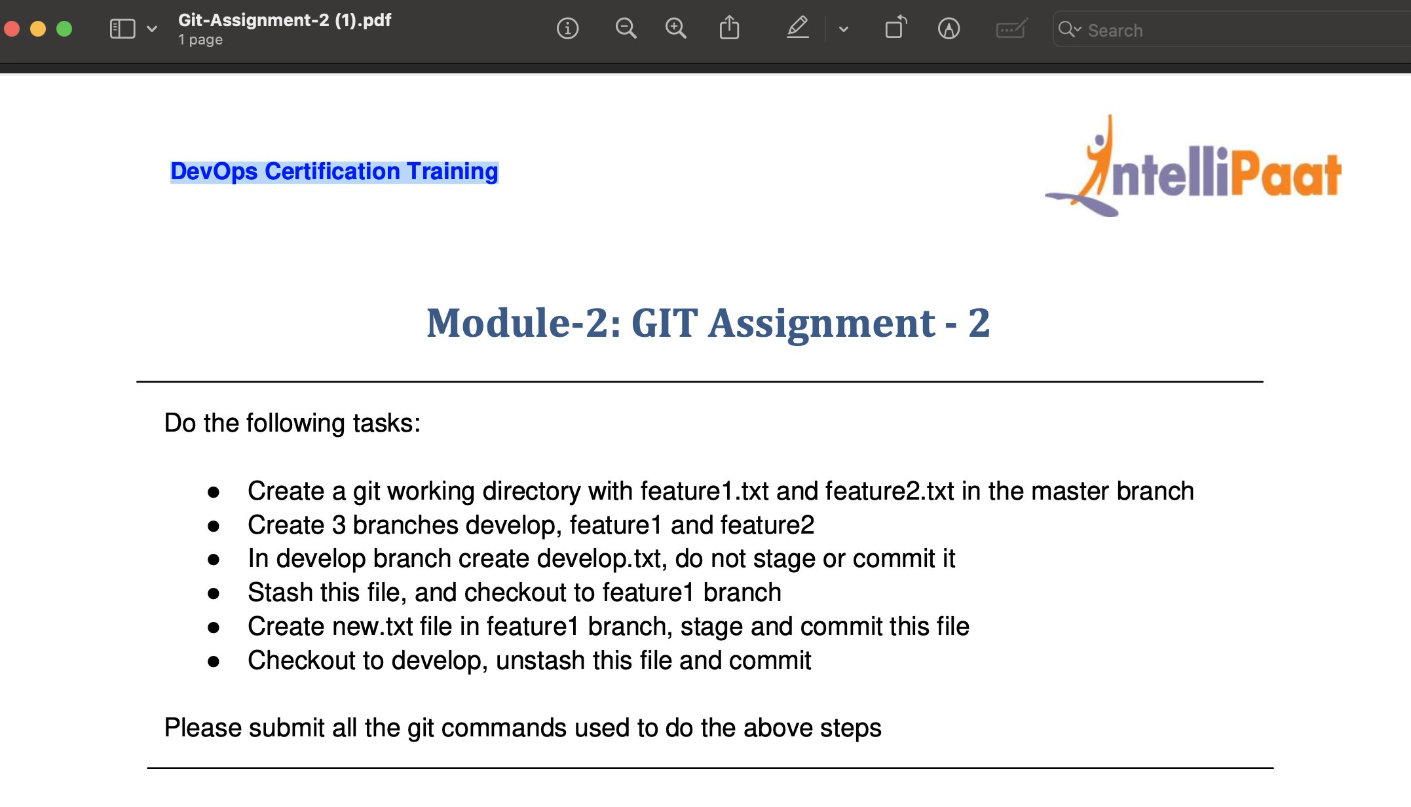

Module-2: GIT Assignment - 2

following tasks:

Create a git working directory with feature1.txt and feature2.txt in the master branch

Create 3 branches develop, feature1 and feature2  
In develop branch create develop.txt, do not stage or commit it  
Stash this file, and checkout to feature1 branch

Create new.txt file in feature1 branch, stage and commit this file Checkout to develop, unstash this file and commit

Please submit all the git commands used to do the above steps

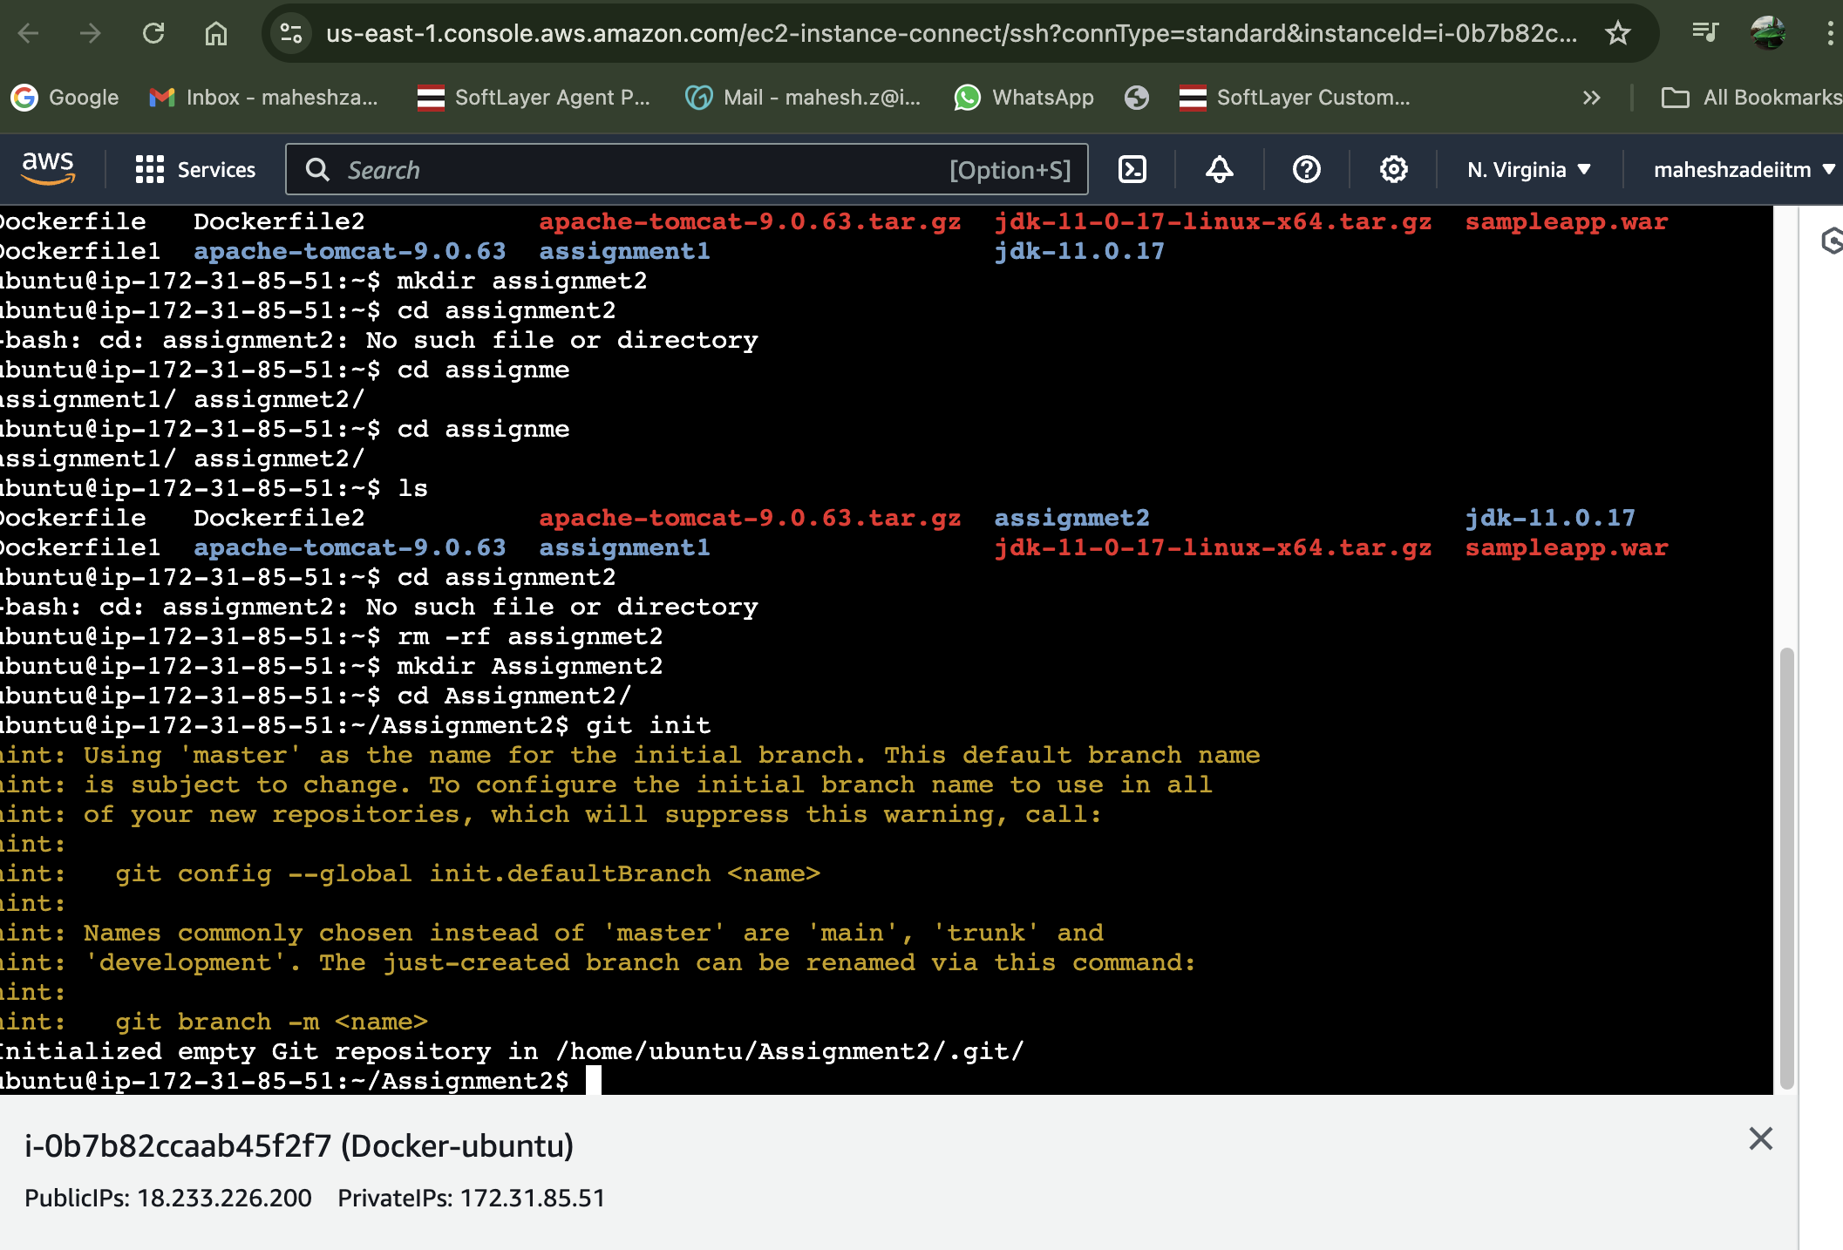

Create a git working directory with feature1.txt and feature2.txt in the master branch Create

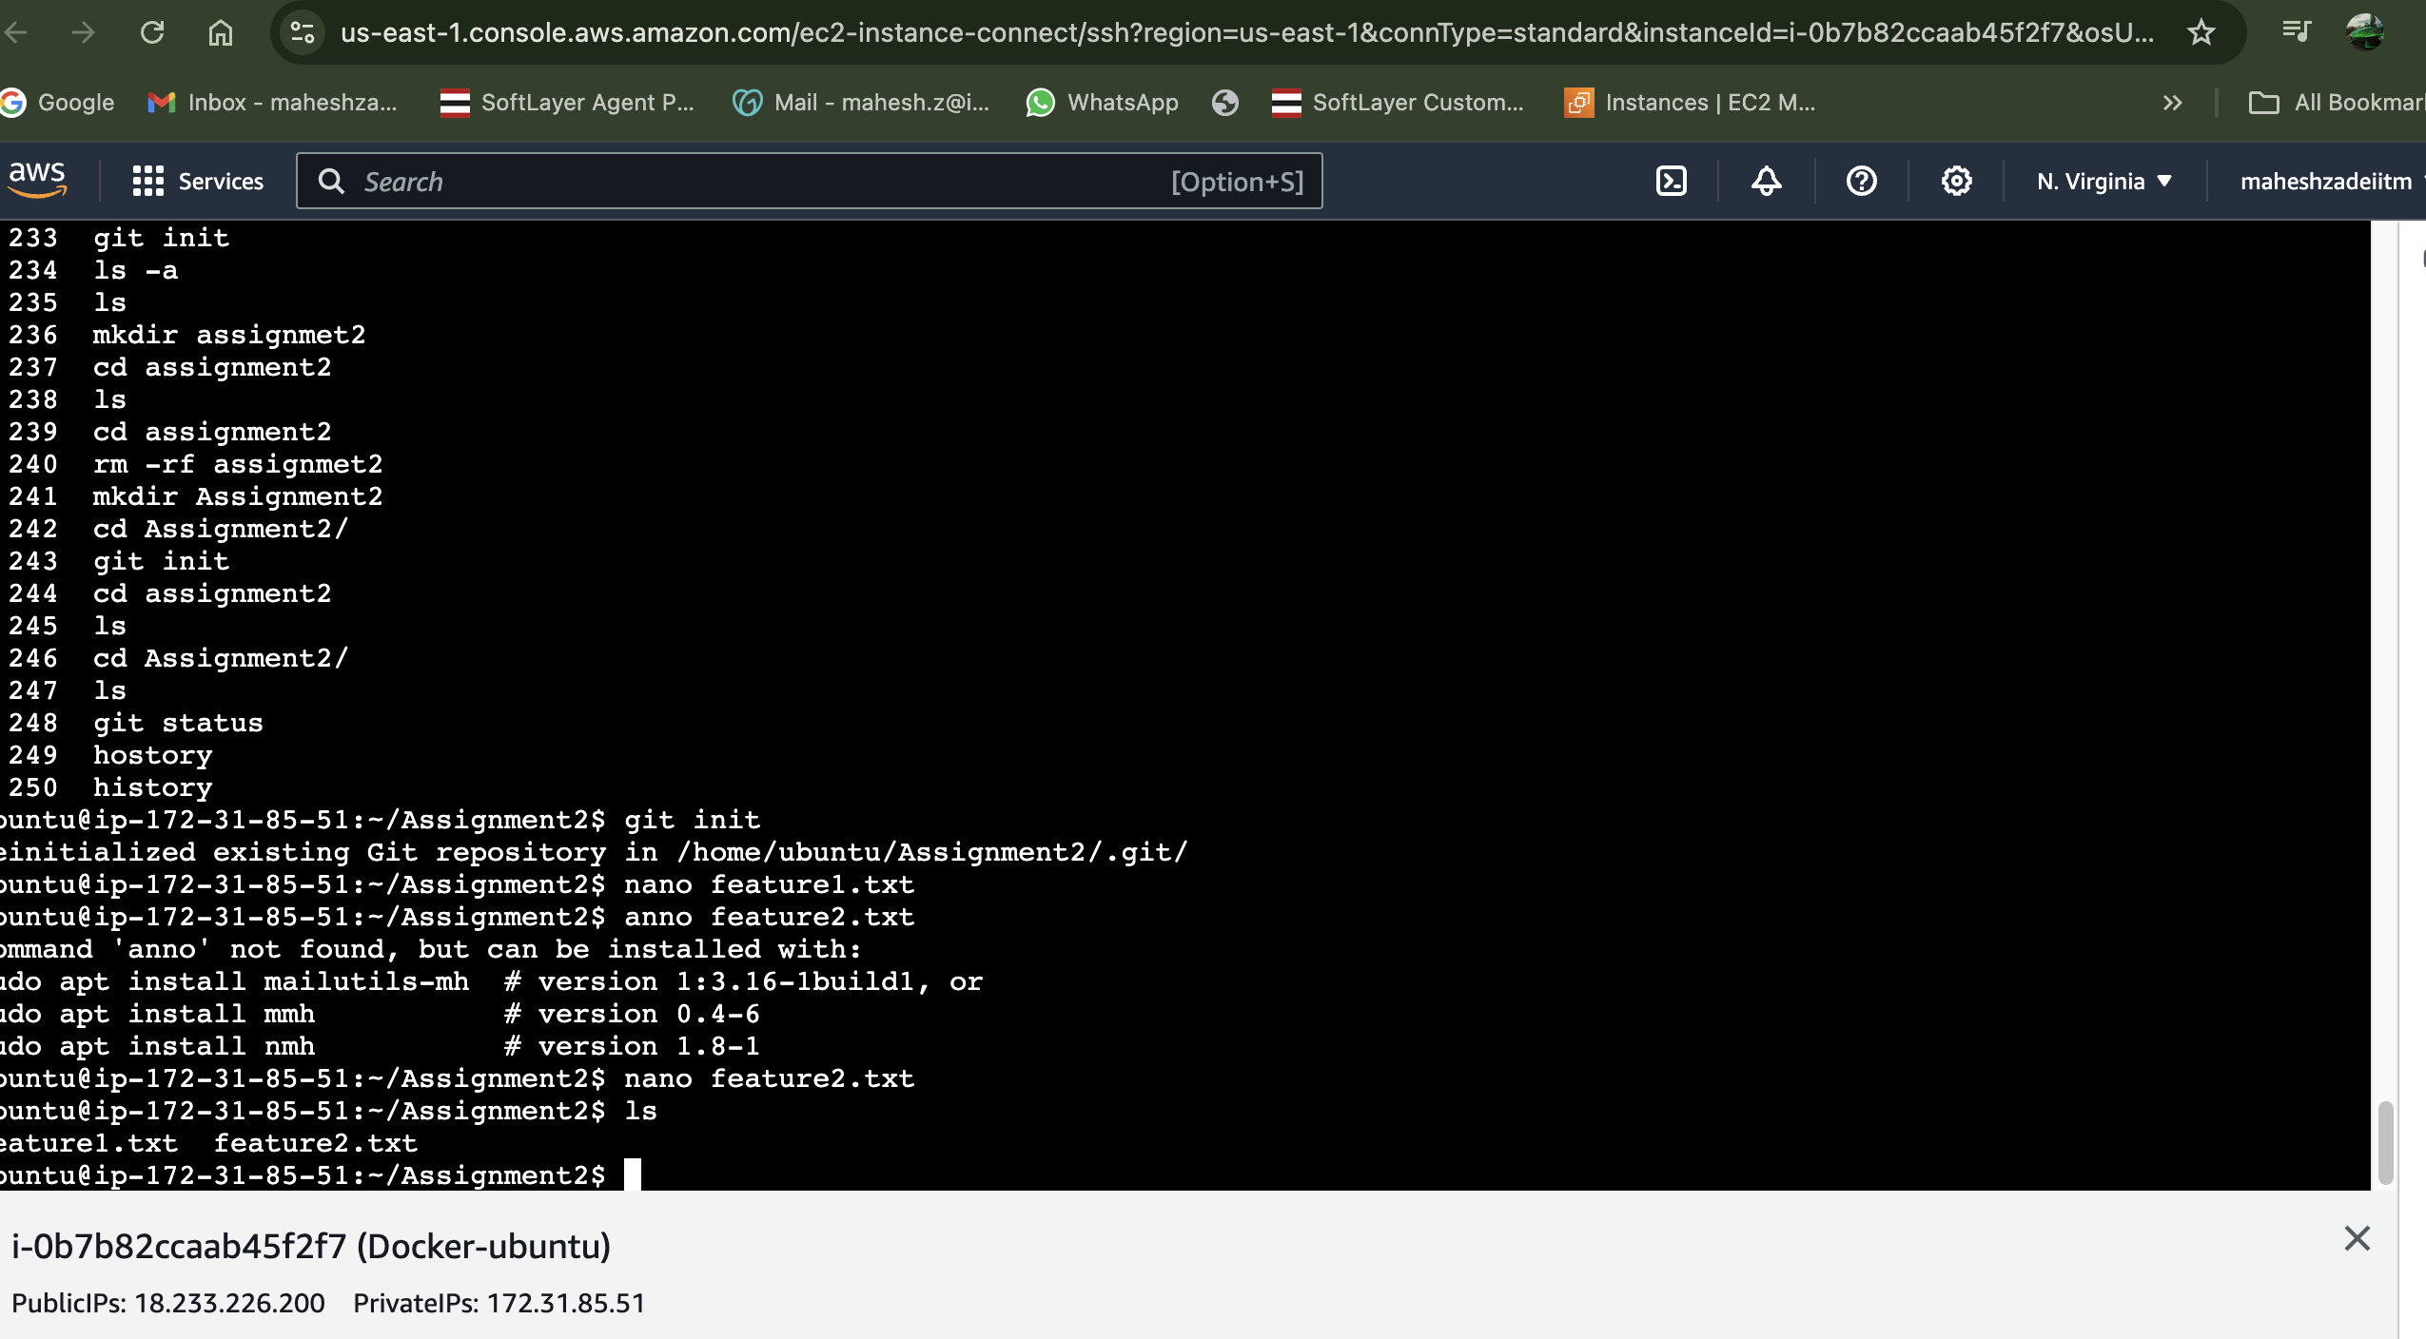

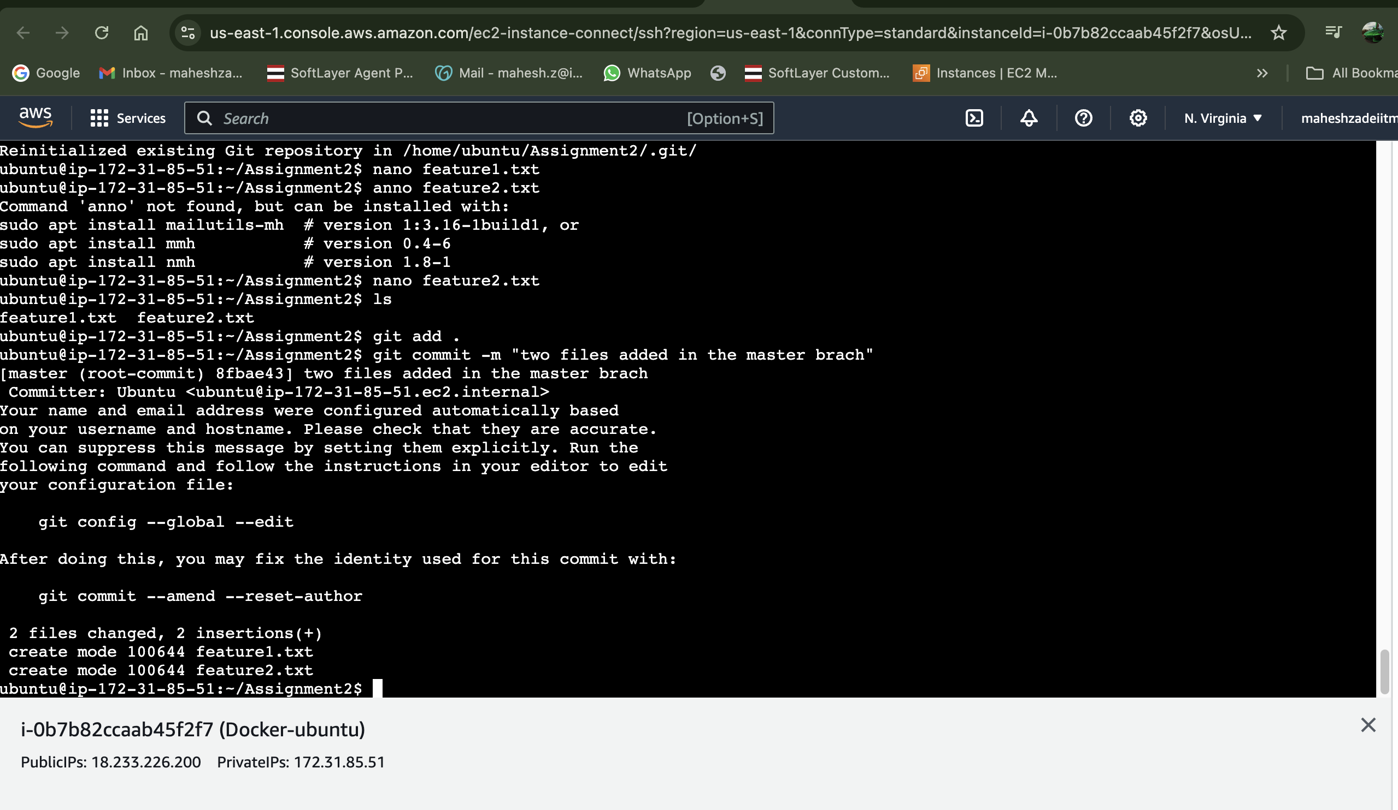

Check git status

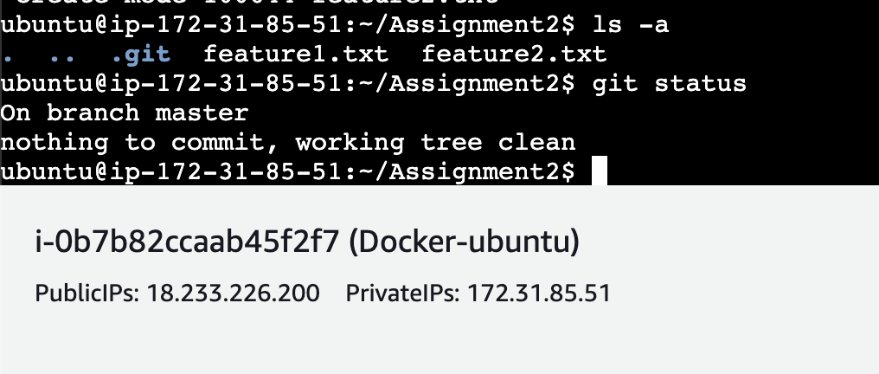

Now Master branch is created

Create 3 branches develop, feature1 and feature2

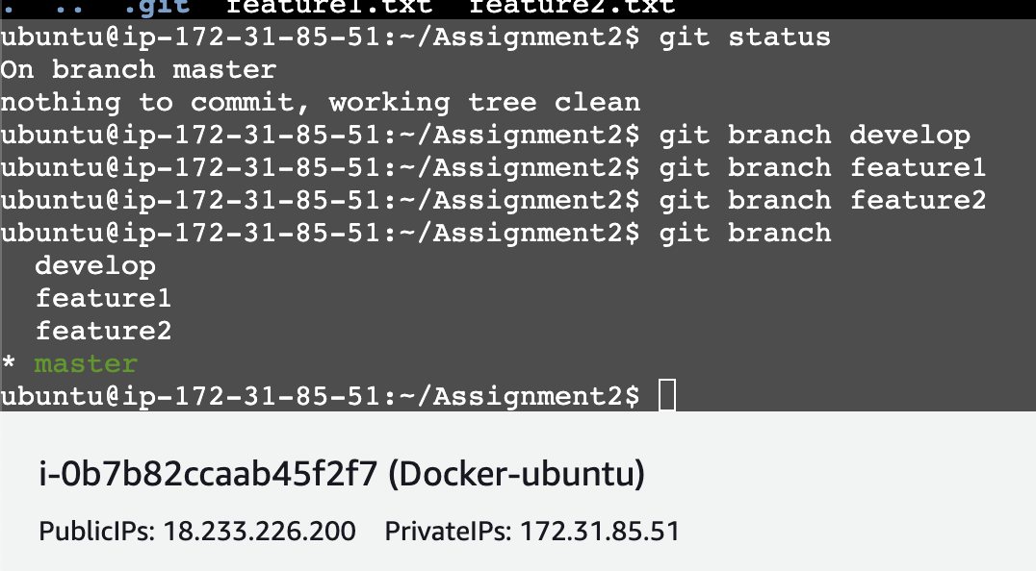

Check git log

ubuntu@ip-172-31-85-51:~/Assignment2$ git log

commit 8fbae4366f0ab181753e9c843104d7b05bbfb385 (HEAD -> master, feature2, feature1, develop)

Author: Ubuntu <ubuntu@ip-172-31-85-51.ec2.internal>

Date: Sun Aug 18 09:14:51 2024 +0000

two files added in the master brach

ubuntu@ip-172-31-85-51:~/Assignment2$

check with git show what happened exactly in the commit id

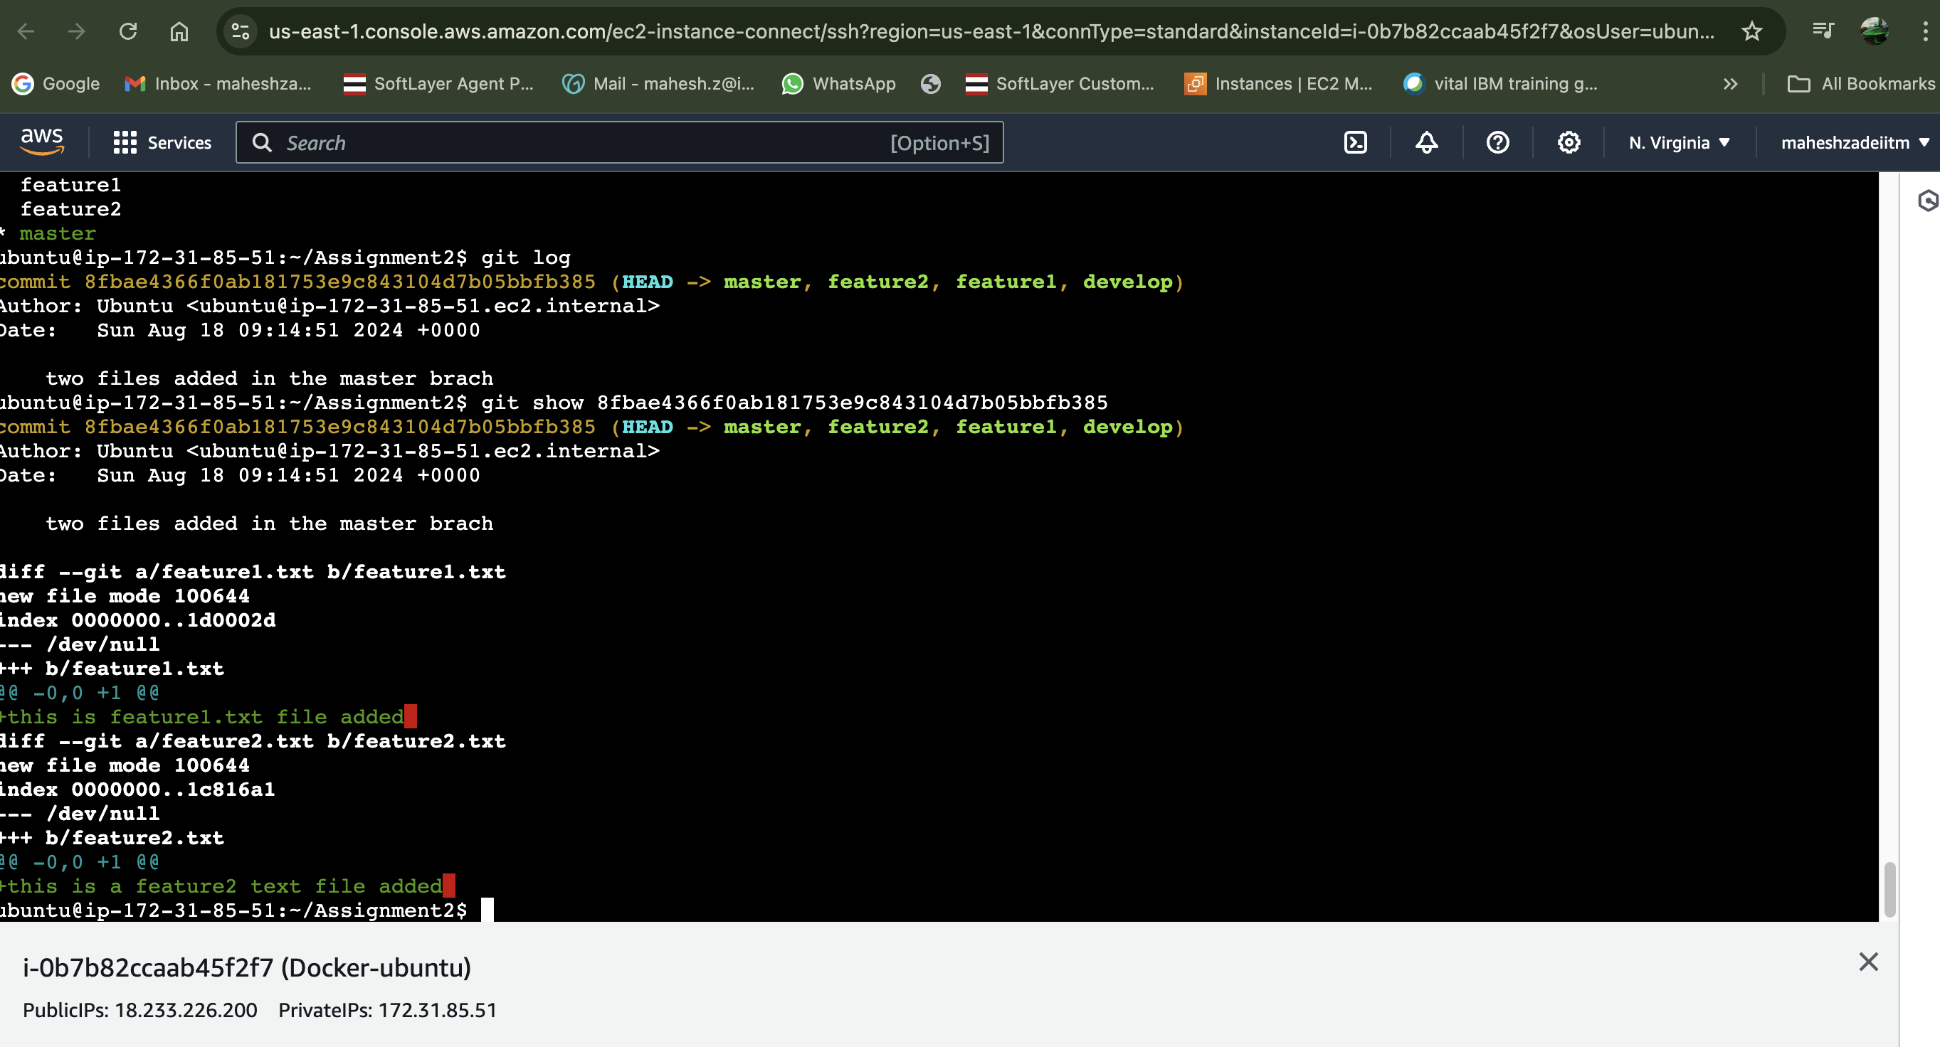

Check all created branch

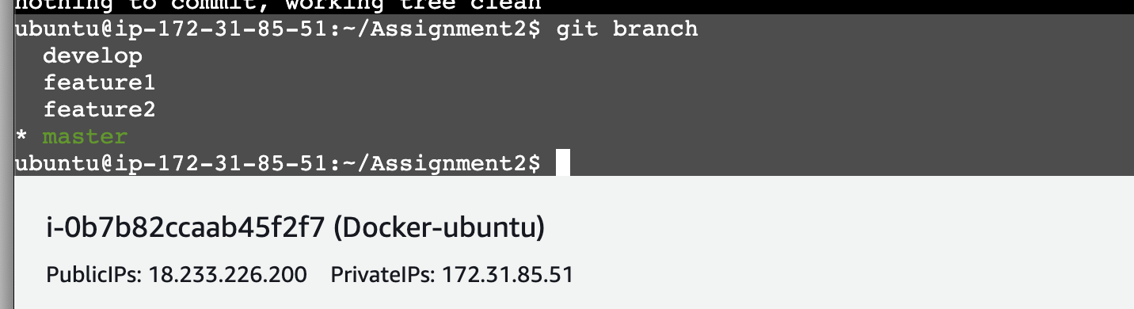

In develop branch create develop.txt, do not stage or commit it

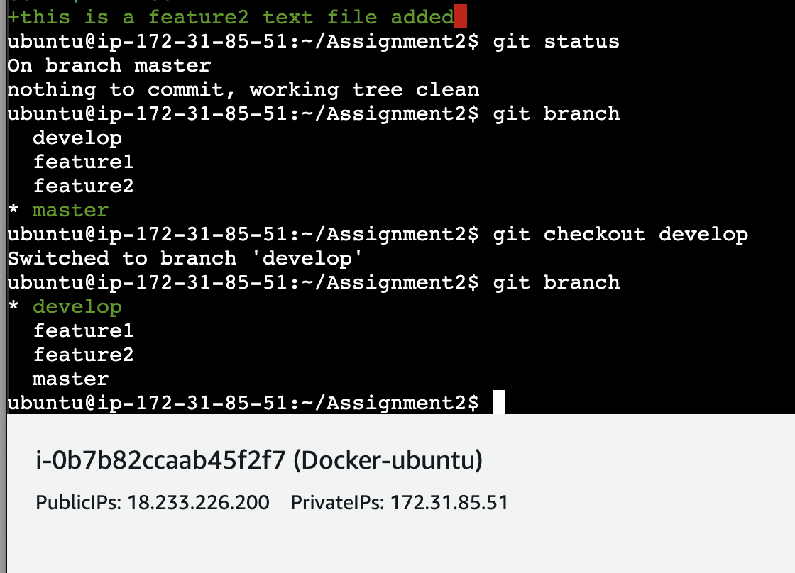

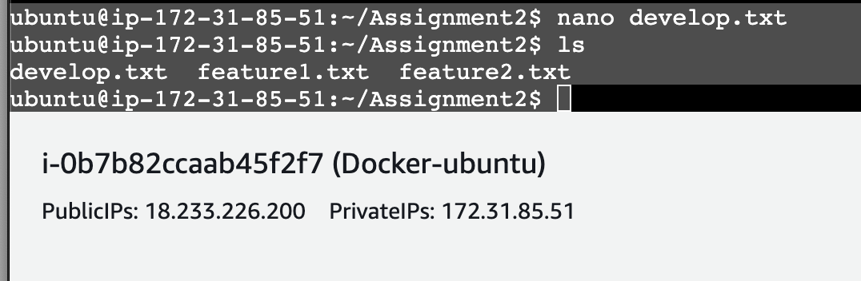

Check git status

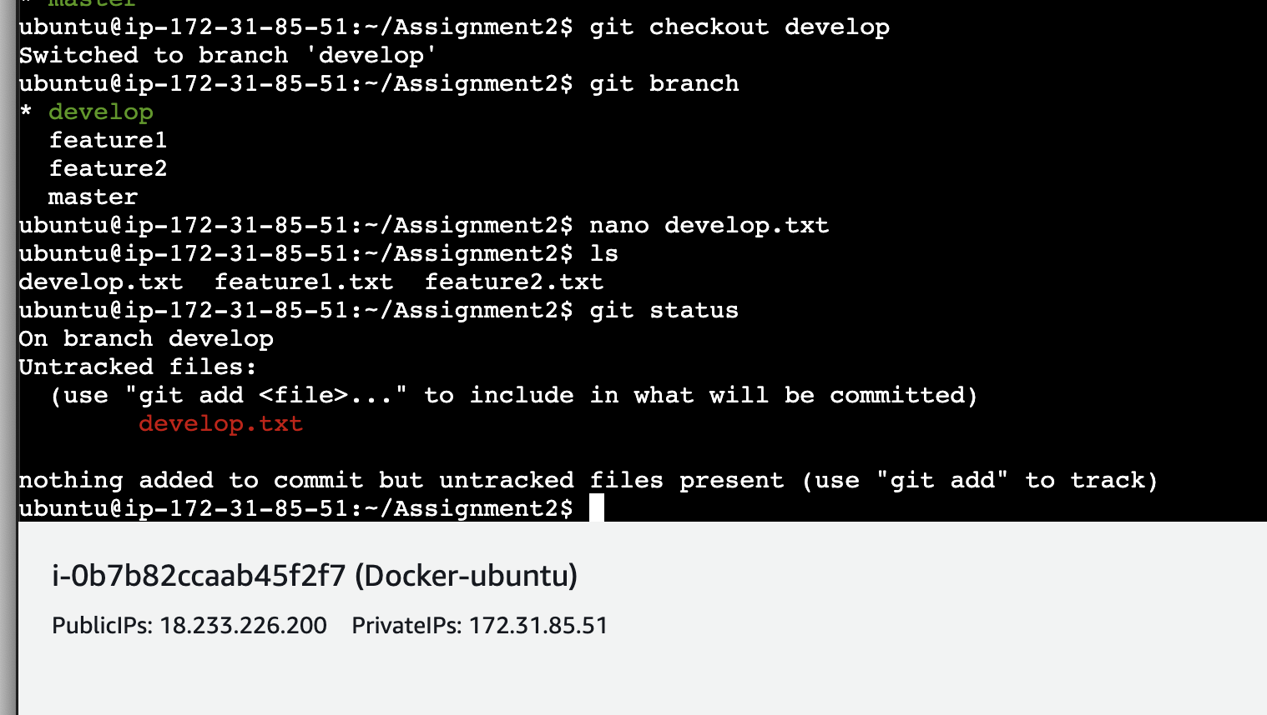

Hide the untracked file

Git stashed -u

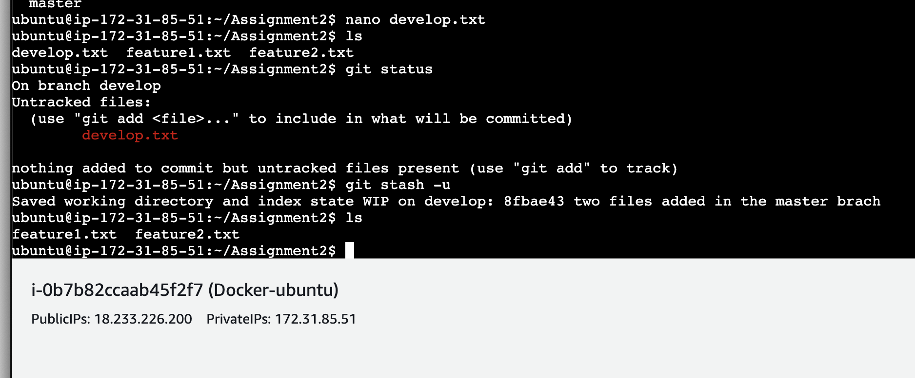

Now develop.txt is hiden file , it now showing after ls

Create new.txt file in feature1 branch, stage and commit this file Checkout to develop, unstash this file and commit

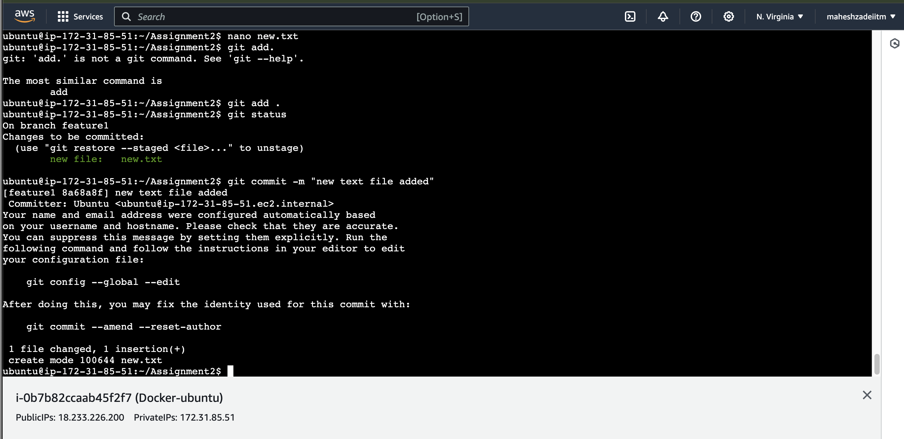

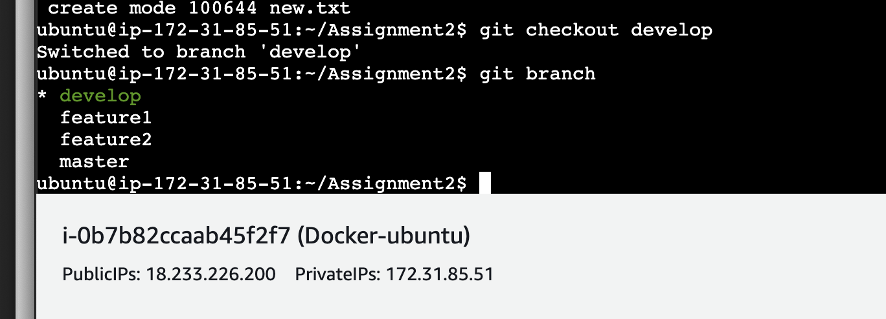

ubuntu@ip-172-31-85-51:~/Assignment2$ git branch

\* develop

feature1

feature2

master

ubuntu@ip-172-31-85-51:~/Assignment2$ ls

feature1.txt feature2.txt

ubuntu@ip-172-31-85-51:~/Assignment2$

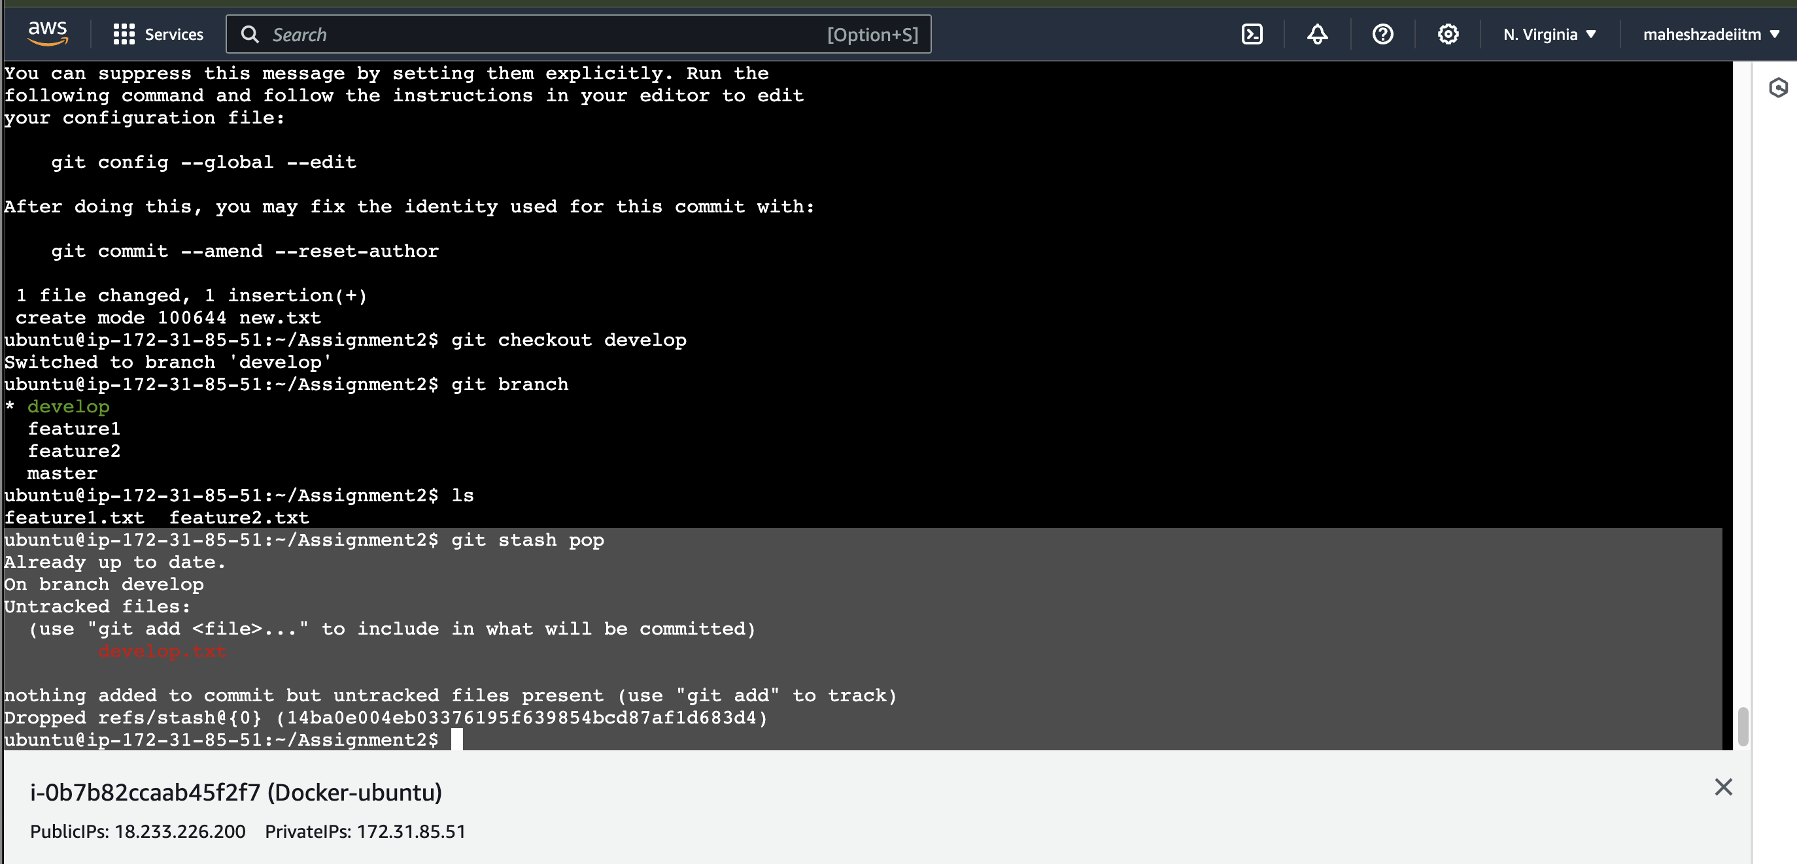

Unhide the stashed file

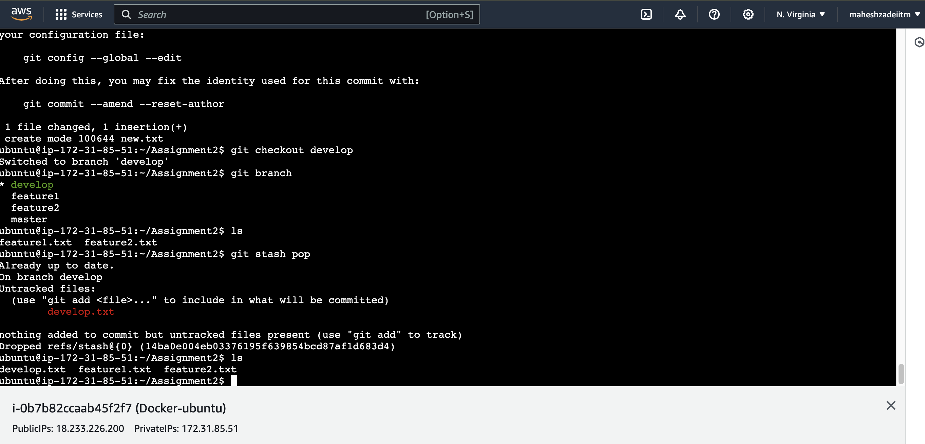

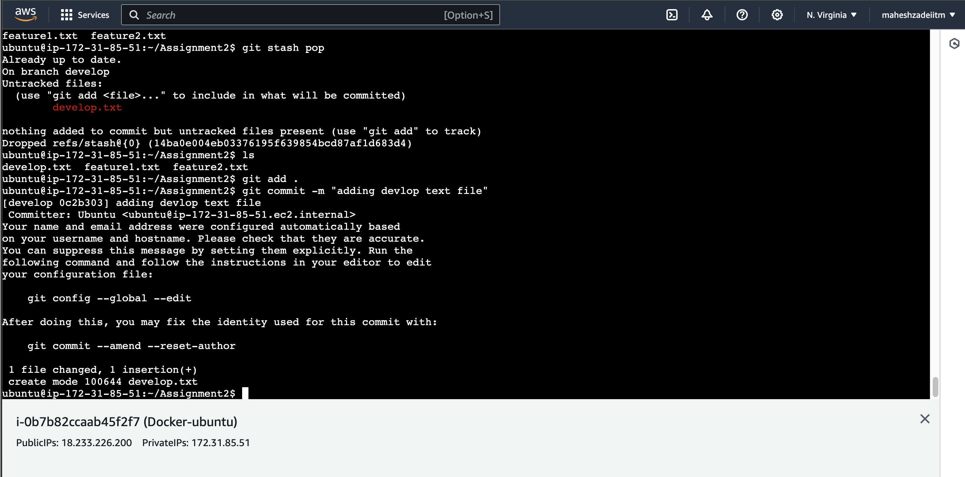

Now the file is commited check the git status

ubuntu@ip-172-31-85-51:~/Assignment2$ git status

On branch develop

nothing to commit, working tree clean

ubuntu@ip-172-31-85-51:~/Assignment2$

git all commands used fore assignment 2

236 mkdir assignmet2

237 cd assignment2

238 ls

239 cd assignment2

240 rm -rf assignmet2

241 mkdir Assignment2

242 cd Assignment2/

243 git init

244 cd assignment2

245 ls

246 cd Assignment2/

247 ls

248 git status

249 hostory

250 history

251 git init

252 nano feature1.txt

253 anno feature2.txt

254 nano feature2.txt

255 ls

256 git add .

257 git commit -m "two files added in the master brach"

258 ls -a

259 git status

260 git branch develop

261 git branch feature1

262 git branch feature2

263 git branch

264 git log

265 git show 8fbae4366f0ab181753e9c843104d7b05bbfb385

266 git status

267 git branch

268 git checkout develop

269 git branch

270 nano develop.txt

271 ls

272 git status

273 git stash -u

274 ls

275 git checkout feature1

276 git status

277 git branch

278 nano new.txt

279 git add.

280 git add .

281 git status

282 git commit -m "new text file added"

283 git checkout develop

284 git branch

285 ls

286 git stash pop

287 ls

288 git add .

289 git commit -m "adding devlop text file"

290 git status

291 history

ubuntu@ip-172-31-85-51:~/Assignment2$

Assignment2 is completed successfully

